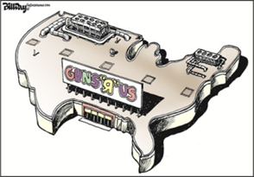

TASK: What ist he message of this cartoon? To what extent can mass shootigs be prevented in the future? (300words)

