TP 1: Final Exam

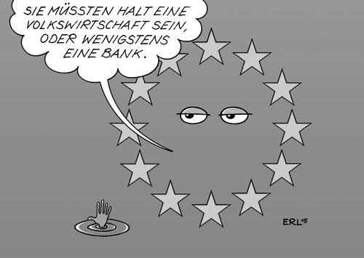

Cartoon analysis

TASK: What message does this cartoon convey about the EU? Do you think this is an accurate representation oft he current situation? (300 words)

Background colour: blue
Colour of stars: yellow

