Quelle
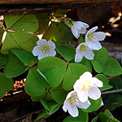 | Rudolf Schäfer  https://www.flickr.com/photos/schaefer-rudolf/6720992117/in/photolist-j3fWDt-dhPVD6-j97XQE-7p9koC-akVvME-akVvfm-akVv21-akVuMC-akVuzN-akSFSp-akSFEp-akVtVJ-akSGXZ-dhPVLt-dhPVFo-dhPVyQ-bVsLDK-bVsLWP-j3epG2-j95GY7-wUSXwh-pmb9qm-8uMyCR-mEt6y6-4RtVLm-czk7Kj-niqsdT-nzV8jc-nxSrj9-nzC9Sn-bMF62p-cjrDYo-beUR6n-beURjt-beURgp-beURbM-beUR1n-beUQSF-beUQNr-deV3zt-ncv8fn-ncuNaa-faxCN4-faMTt5-eiGS1W-v7q6zm-voZEhP-vpi1G8-nJTz2p-nsp7RK/
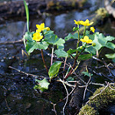 | Sören  https://www.flickr.com/photos/soeren_nb/13956162181/in/photolist-9Cp5q7-yzapKA-bKm8Jr-bKm8FH-bwrnVb-bwrorW-bwrooQ-bwrohh-bwrodJ-bKm8Q4-bKm9bv-7TtCeD-ngfZrj-ngfYMT-ngxhir-ngxinv-6eyr4G-bBsbRQ-nCNuf7-nmWdbX-fiwtqj-ntMbz2-bQBsTF-nchRUS-ntvhnJ-9j8TwV-daQZj-9j7vnn-eotX1X-nrJPLq-nspFfa-7SdibJ-9j7uYX-dgLr51-6kk5Yg-6mc4xM-7Sa3RD-kKAZvt-FE1fW-ng5yH2-byqwQj-naseTP-vprvRp-v7vPeU-vpkxfP-tocmxz-t6yeuf-srfLoX-277Bv-9FDhBu/
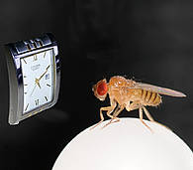 | Mainpost
Modulbilder
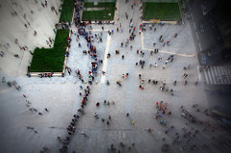  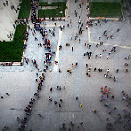 | Martin Fisch  https://www.flickr.com/photos/marfis75/8382091621/in/photostream/
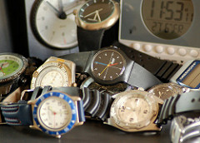  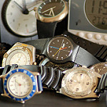 | Günter Hentschel  https://www.flickr.com/photos/v230gh/14332707618/
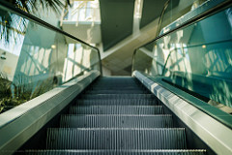  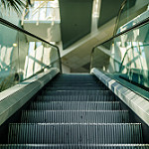 | Mario Goebbels  https://www.flickr.com/photos/cerealbawx/17253304302/
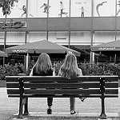 | Dirk Förster  https://www.flickr.com/photos/dfoerster_fotografie/22456925207/in/photostream/
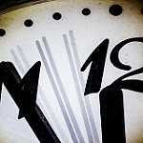 | Dennis Skley  https://www.flickr.com/photos/dskley/9545050239/

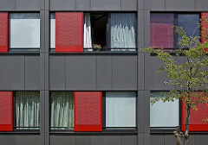 | Digital Cat  https://www.flickr.com/photos/14646075@N03/3617139479/in/photostream/
Stiller Beobachter
https://www.flickr.com/photos/a-herzog/5249841186/

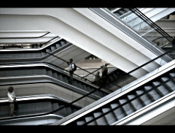 | Alexander  https://www.flickr.com/photos/15082599@N08/2761315870/

